AMS 333 HW# 3

Ivan Tinov

110255332

Ivan Tinov 110255332

***Population dynamics of rabbits and foxes – Lotka-Volterra Model***

**Introduction**

The study of Population Dynamics is all about how species reproduce and how populations of species grow over time. However, different organisms reproduce in different ways that can be modeled using different mathematical models. Single-celled organisms produce asexually in which an offspring is produced from a single organism and therefore only inherits the genes of one parent. Likewise, gametes are not fused, and the chromosome number never changes. On the contrast, sexually reproductive organisms, like rabbits and foxes, need the genetic information of two multi-cellular organisms of different sexes. In higher level organisms, such as in human reproduction, the male sex produces a small mobile gamete that travels to fuse with a larger stationary gamete that is produced by the female organism.

The Lotka-Volterra model for prey-predator relationships is one of the fundamental models in population dynamics. The model revolves around a predator population that benefits while the prey population suffers and is characterized by the predator population eating the prey population. The assumptions in this model revolve around an exponential growth of prey population if the predator population is zero. Similarly, there is a linear growth in both predator and prey population, meaning that more predators will eat more prey if both populations grow.

The Lotka-Volterra model is characterized by two differential equations that explain how predator and prey populations change over time:

dNprey/dt = Ro,prey * Nprey(t) – y * Nprey(t) * Npred(t)

dNpred/dt = e * y * Nprey(t) * Npred(t) - Ro,pred * Npred(t)

For the equations above, N represents predator/prey population density at time, t, Ro,prey is the per capita growth rate of the prey population, and Ro,pred is the per capita death rate of the predator population. Similarly, y is the per capita predation rate, and e can be seen as how efficient the increase in reproductive capability obtained by a predator upon eating a member of the prey population.

**Methods Analysis**

For this model we consider rabbits as prey and foxes as predators using the Lotka-Volterra model with the given parameters: e = 0.1, y = 0.0005, Ro,pred = 0.2, Ro,prey = 0.04.

We will use the Forward-Euler method to compute the evolution of time for the Lotka-Volterra model so that we can get a precise calculation of how different values will have an effect. The Forward-Euler method can be represented as x(t + Δt) = x(t) + dx/dt * (Δt), where the derivative of this mathematical equation is evaluated at current time. For the Lotka-Volterra model we will analyze initial populations of 200 rabbits/km^2 and 50 foxes/km^2. We will try different values of 5000 rabbits/km^2, 100 foxes/km^2 and 4000 rabbits/km^2 and 80 foxes/km^2, using a time step of 0.01 days.

**Simple Lotka–Volterra Model**

For populations of 200 rabbits/km^2 and 50 foxes/km^2, we see prey and predator populations vary over the course of the year in which the predator population ranges from 0 all the way to around 1200. The prey population ranges from around 200 to over 18,000 which shows that the predator population can die out eventually when the prey population becomes low. This happens when the prey population is too low to support the predator population. This can be seen in Figure 1 of the diagrams below.

When tried with populations of 5000 rabbits/km^2 and 100 foxes/km^2, we can see now that the prey population can be high enough to sustain all the predators and prevent them from ever reaching zero value. There is an observed 50:1 prey-predator ratio. This can be observed in Figure 2 of the diagrams below.

Likewise, populations of 4000 rabbits/km^2 and 80 foxes/km^2 we can see that the ratio is preserved, and we have a steady population of around 265 prey and a steady population of 80 predators for the duration. This is a state where the prey and predator populations coexist and have equilibrium. This represents a difference from the varying nature of the other population numbers. This can be seen in Figure 3 of the diagrams below.

**Lotka-Volterra Model with Carrying Capacity**

The Lotka-Volterra model has a very varying nature, and this falls in with the nature of biology. If there is no predator population, then the prey population will grow exponentially, and will reach a state where the model will not accurately represent realistic conditions in nature. Therefore, we must introduce a carrying capacity to circumvent this occurrence. We do this by replacing Ro,prey with Ro,prey * (1 – Nprey(t)/K), where K represents the carrying capacity of the actual environment. This addition to the model will introduce realistic conditions to the capacity of the environment such as space and resources.

A population of 200 rabbits/km^2 and 50 foxes/km^2, we can see that the values for the population of prey range from around 400 to 9000 rabbits. The predator population ranges from 0 to around 230 foxes. The population is centered at 4000 rabbits and 50 foxes. We can see that the prey and predator populations decreased by over 50% for rabbits at max population and 80% for the foxes at max population. This can be seen in Figure 4 of the diagrams below.

At a population of 5000 rabbits/km^2 and 100 foxes/km^2, the population of prey range from around 2800 to around 4800 rabbits. The predator population ranges from 20 to around 120 foxes. The population is centered at around 4000 rabbits and 50 foxes as before. This can be seen in Figure 5 of the diagrams below.

At a population of 4000 rabbits/km^2 and 80 foxes/km^2, the population of prey range from around 3400 to around 4500 rabbits. The predator population ranges from 32 to 80 foxes. The population is centered at around 4000 rabbits and 47 foxes. This can be seen in Figure 6 of the diagrams below.

By introducing a carrying capacity, we can see that both the predator and prey populations have lowered since we have introduced a realistic limitation in the resources provided by the environment. The predator population lowered a lot more than the prey population since predators need to eat prey to survive. For all three conditions of varying rabbit and fox populations we can see that each condition centers at around 4000 rabbits and 50 foxes.

**Lotka-Volterra Model with Carrying Capacity & Predation Limit**

The predation rate can also be adjusted alongside the carrying capacity, where the predation rate was linear in both predator and prey populations. Using the equation t = T – h*N, where N represents number of prey consumed, T is time spent getting food, and h is the time spent killing and eating while prey has been found. If the number of prey caught increases with the density of prey and the time finding prey, we can model the following equation: N = s*U*t, which is equivalent to N = s*U*(T – h*N). This can be rearranged in the following equation N/T = s*U*(1 + s*h*U), which represents the per capita predation rate. U represents the prey population density, and s is a constant that represents proportions of prey and predators. When prey populations are low, s = y, which equals the per capita predation rate. As prey populations increase, the predation rate becomes a constant value of 1/h and depends on the time spent killing and eating.

A population of 200 rabbits/km^2 and 50 foxes/km^2, we can see that the values for the population of prey range from around 2 to 100 rabbits. The predator population ranges from 0 to around 70 foxes. We can see that the prey and predator populations at max decreased by a huge amount by the addition of predation limit and carrying capacity. This can be seen in Figure 7 of the diagrams below.

At a population of 5000 rabbits/km^2 and 100 foxes/km^2, the population of prey range from around 46 to around 75 rabbits. The predator population ranges from 20 to around 55 foxes. This can be seen in Figure 8 of the diagrams below.

At a population of 4000 rabbits/km^2 and 80 foxes/km^2, the population of prey range from around 40 to around 80 rabbits. The predator population ranges from 15 to 60 foxes. This can be seen in Figure 9 of the diagrams below.

Overall, when introducing predation limit on top of carrying capacity, the Lotka-Volterra has more realistic parameters that provide a more limited interpretation of predator-prey interaction in nature. However, this environmentally limited model we can see that there is a low predation rate, due to a large search time for prey, and the very small predator population cannot sustain all the predators. Therefore, there are not enough prey for the predators to survive in lower populations like 200 rabbits/km^2 and 50 foxes/km^2.

**Diagrams**

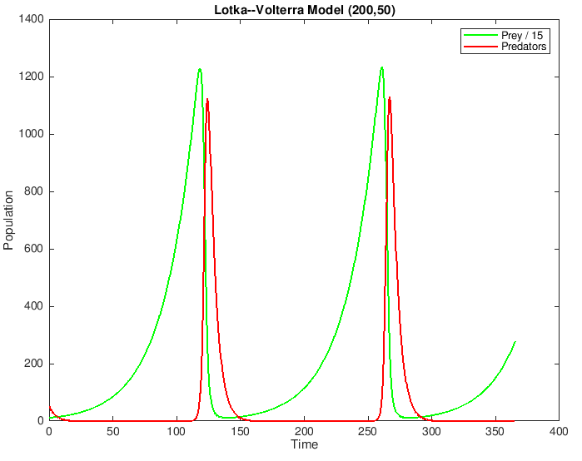

Figure 1: Lotka-Volterra Model (200,50)

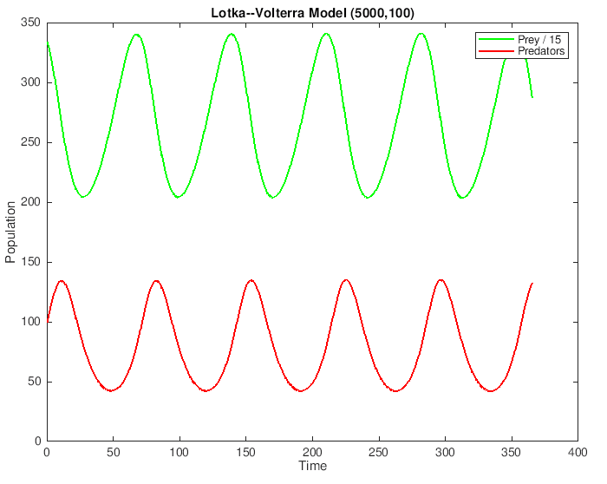

Figure 2: Lotka-Volterra Model (5000,100)

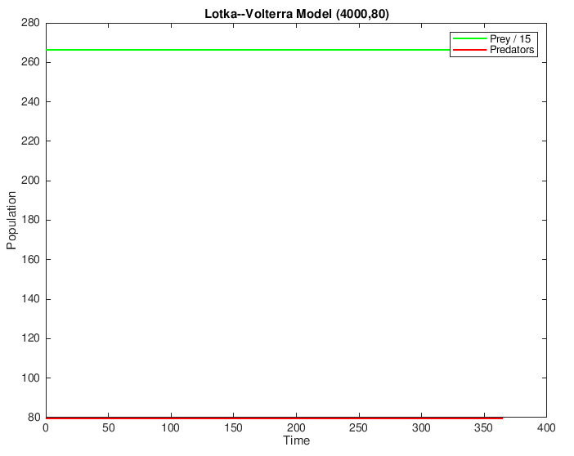

Figure 3: Lotka-Volterra Model (4000,80)

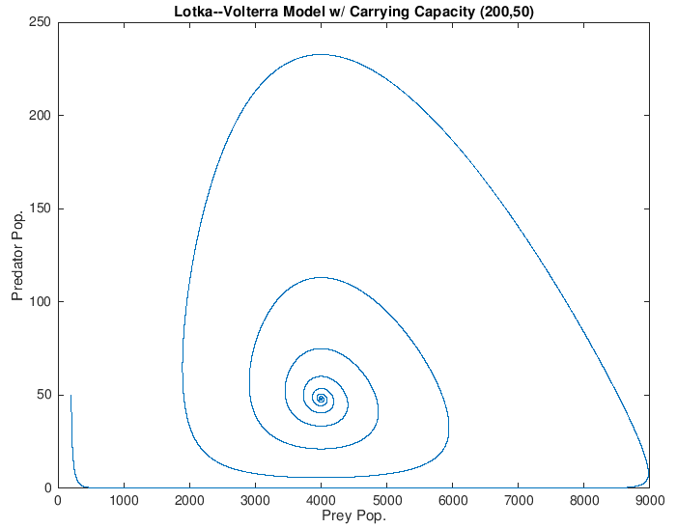

Figure 4: Lotka-Volterra model w/ Carrying Capacity (200,50)

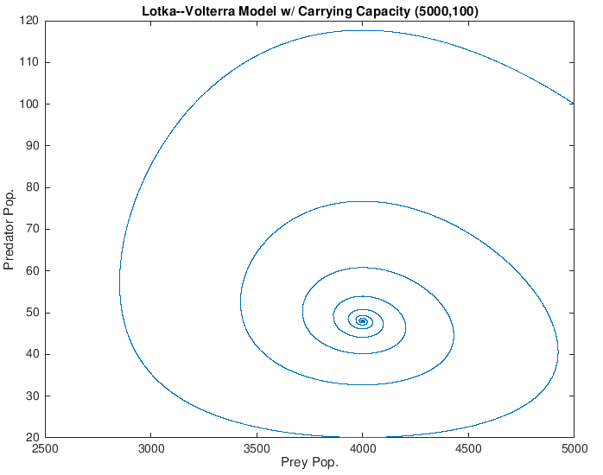

Figure 5: Lotka-Volterra model w/ Carrying Capacity (5000,100)

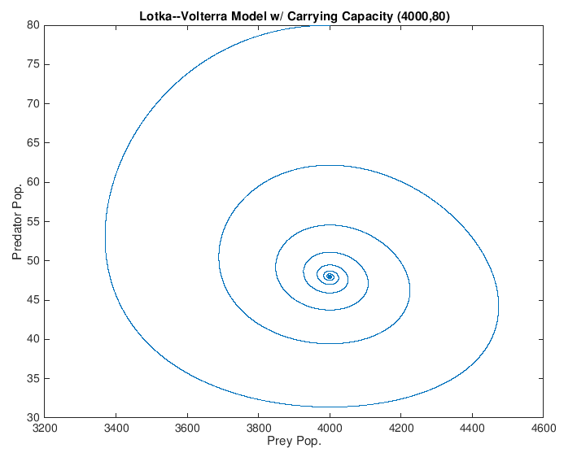

Figure 6: Lotka-Volterra model w/ Carrying Capacity (4000,80)

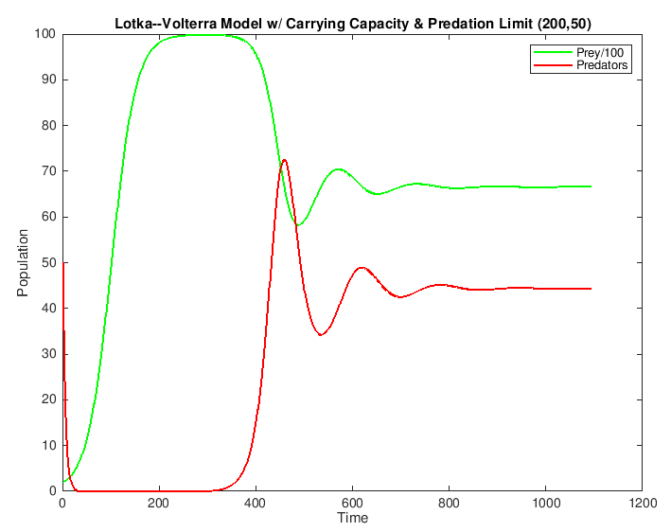

Figure 7: Lotka-Volterra model w/ Carrying Capacity and Predation Limit (200,50)

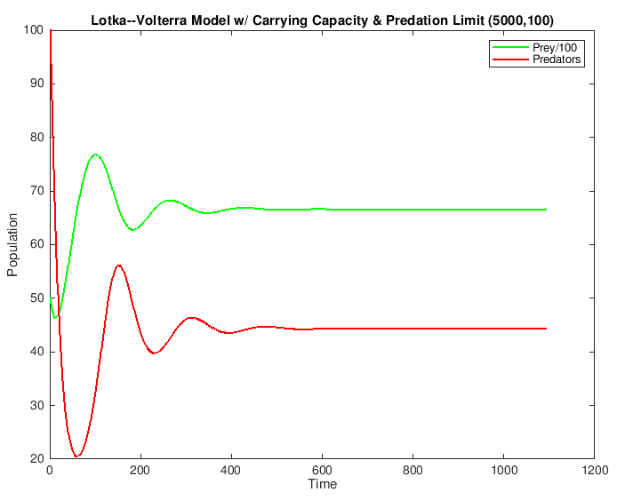

Figure 8: Lotka-Volterra model w/ Carrying Capacity and Predation Limit (5000,100)

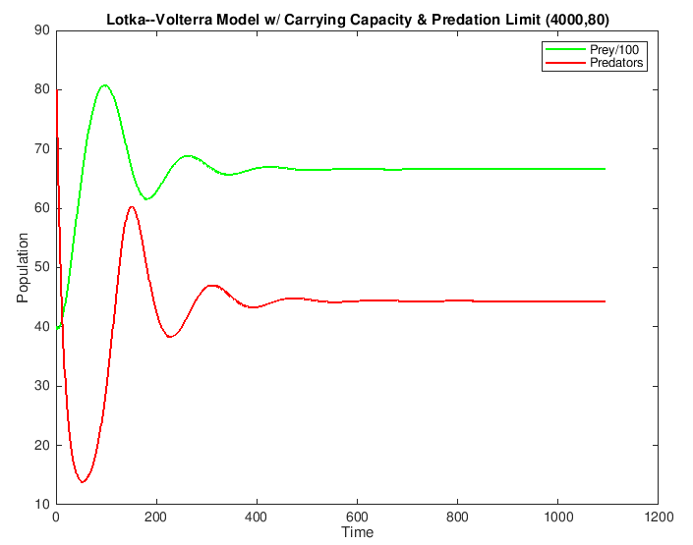

Figure 9: Lotka-Volterra model w/ Carrying Capacity and Predation Limit (4000,80)

**Matlab Code**

1. *LotkaVolterra.m*

% Lotka-Volterra Model

Nprey = zeros(36500,1);

Npred = zeros(36500,1);

Nprey(1) = 4000; % 200, 5000, 4000

Npred(1) = 80; % 50, 100, 80

delta = 0.01;

Rprey = 0.04;

Rpred = 0.2;

g = 0.0005;

e = 0.1;

t = 0:0.01:365;

for n = 1:36500

dNpreydt = (Rprey * Nprey(n)) - g * Nprey(n) * Npred(n);

dNpreddt=(e * g * Nprey(n) * Npred(n)) - Rpred * Npred(n);

Nprey(n + 1) = Nprey(n) + (dNpreydt * delta);

Npred(n + 1) = Npred(n) + (dNpreddt * delta);

end

plot(t,Nprey/15,'g','LineWidth',1.5);

hold on

plot(t,Npred,'r','LineWidth',1.5);

xlabel('Time');

ylabel('Population');

title('Lotka-­Volterra Model (4000,80)');

legend('Prey / 15','Predators');

disp('LotkaVolterra','­pdf');

hold off

plot(Nprey,Npred);

1. *LotkaVolterra_cap.m*

% Lotka-Volterra Model with Carrying Capacity

Nprey = zeros(109500,1);

Npred = zeros(109500,1);

Nprey(1) = 4000; % 200, 5000, 4000

Npred(1) = 80; % 50, 100, 80

delta = 0.01;

Rprey = 0.04;

Rpred = 0.2;

g = 0.0005;

e = 0.1;

t = 0:0.01:1095;

K = 10000;

for n = 1:109500

dNpreydt = Rprey * Nprey(n) * (1 - (Nprey(n) / K)) - g * Nprey(n) * Npred(n);

dNpreddt = e * g * Nprey(n) * Npred(n) - Rpred * Npred(n);

Nprey(n + 1) = Nprey(n) + dNpreydt * delta;

Npred(n + 1) = Npred(n) + dNpreddt * delta;

end

plot(Nprey,Npred);

xlabel('Prey Pop.');

ylabel('Predator Pop.');

title('Lotka­-Volterra Model w/ Carrying Capacity (4000,80)');

1. *LotkaVolterra_cap_pred.m*

% Lotka-Volterra Model with Carrying Capacity & Predation

Nprey = zeros(109500,1);

Npred = zeros(109500,1);

Nprey(1) = 4000; % 200, 5000, 4000

Npred(1) = 80; % 50, 100, 80

delta = 0.01;

Rprey = 0.04;

Rpred = 0.2;

g = 0.0005;

e = 0.1;

t = 0:0.01:1095;

K = 10000;

h = 0.2;

for n = 1:109500

dNpreydt = Rprey * Nprey(n) * (1 - Nprey(n) / K) - g * Nprey(n) * Npred(n) / (1 + g * h * Nprey(n));

dNpreddt = e * g * Nprey(n) * Npred(n) / (1 + g * h * Nprey(n)) - Rpred * Npred(n);

Nprey(n + 1) = Nprey(n) + dNpreydt * delta;

Npred(n + 1) = Npred(n) + dNpreddt * delta;

end

plot(t,Nprey/100,'g','LineWidth',1.5);

hold on

plot(t,Npred,'r','LineWidth',1.5);

xlabel('Time');

ylabel('Population');

title('Lotka-­Volterra Model w/ Carrying Capacity & Predation Limit (4000,80)');

legend('Prey/100','Predators');

disp('LotkaVolterra_cap_pred','­dpdf');

hold off

plot(Nprey,Npred);